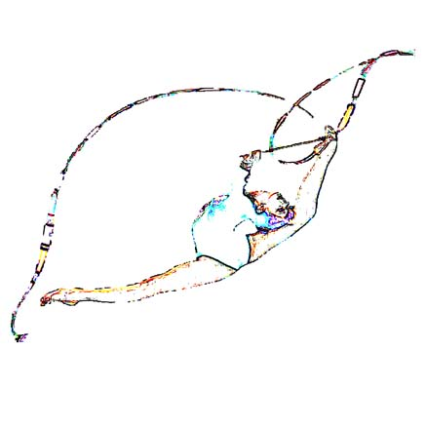


AGN CUP 2015
International tournament in rhythmic gymnastics
Maia / PORTUGAL
25-26 APRIL 2015

DEFINITIVE REGISTRATION FORM

DEADLINE: 01.02.2015

FEDERATION |  | Team/Club:
FEDERATION |  | Contact person:
FEDERATION |  | Phone:
FEDERATION |  | E-mail:

WE WILL PARTICIPATE ON YOUR TOURNAMENT WITH: |  |  | Number of gymnasts, coaches ...
WE WILL PARTICIPATE ON YOUR TOURNAMENT WITH: | Gymnasts | JUNIOR
WE WILL PARTICIPATE ON YOUR TOURNAMENT WITH: | Gymnasts | SENIOR
WE WILL PARTICIPATE ON YOUR TOURNAMENT WITH: | Coach
WE WILL PARTICIPATE ON YOUR TOURNAMENT WITH: | Judge |  | 1
WE WILL PARTICIPATE ON YOUR TOURNAMENT WITH: | Extra-persons
WE WILL PARTICIPATE ON YOUR TOURNAMENT WITH: | TOTAL PERSONS:

Please send to:
agncup@agn.pt

____________________________ __________________________
(Place and date) (Signature & name)

Send before 01.02.2015

AGN CUP 2015
International tournament in rhythmic gymnastics
Maia / PORTUGAL
25-26 APRIL 2015

NOMINATIVE FORM

DEADLINE: 01.03.2015

FEDERATION |  | Team/Club:
FEDERATION |  | Contact person:
FEDERATION |  | Phone:
FEDERATION |  | E-mail:

 | NAME, FAMILY NAME | DATE OF BIRTH | FUNCTION | AGE CATEGORY
1. |  |  | GYMNAST
2. |  |  | GYMNAST
3. |  |  | GYMNAST
4. |  |  | GYMNAST
5. |  |  | COACH | ___
6. |  |  | JUDGE | BREVET
7. |  |  | EXTRA-PERSON | ___

Please send to:
agncup@agn.pt

__________________________ __________________________
(Place and date) (Signature & name)

Send before 01.03.2015

AGN CUP 2015
International tournament in rhythmic gymnastics
Maia / PORTUGAL
25-26 APRIL 2015

TRAVEL SCHEDULE FORM

DEADLINE: 15.03.2015

FEDERATION |  | Team/Club:
FEDERATION |  | Contact person:
FEDERATION |  | Phone:
FEDERATION |  | E-mail:

ARRIVAL
OPORTO AIRPORT ( OPO)
DATE
TIME
FLYING FROM
NUMBER OF FLIGHT

DEPARTURE
OPORTO AIRPORT (OPO)
DATE
TIME
FLYING TO
NUMBER OF FLIGHT

Please send to:
agncup@agn.pt

____________________________ __________________________
(Place and date) (Signature & name)

Send before 15.03.2015

AGN CUP 2015
International tournament in rhythmic gymnastics
Maia / PORTUGAL
25-26 APRIL 2015

VISA APPLICATION FORM

DEADLINE: 01.02.2015

FEDERATION |  | Team/Club:
FEDERATION |  | Contact person:
FEDERATION |  | Phone:
FEDERATION |  | E-mail:

FULL NAME | NATIONALITY | BIRTHDAY DATE | PASSPORT NUMBER | EXPIRY DATE OF PASSPORT
1.
2.
3.
4.
5.
6.

Nearest Portuguese embassy (or embassy where you will ask for the visas):
___________________________________________________________________

Your adress: ___________________________________________
___________________________________________
___________________________________________

Please send to:
agncup@agn.pt

____________________________ __________________________
(Place and date) (Signature & name)

Send before 01.02.2015

