
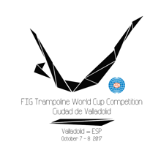

FIG Trampoline World Cup

“Ciudad de Valladolid”
Valladolid - ESP
October 7th – 8th 2017

Organizing Committee / Host Federation
Federación de Gimnasia de Castilla y León
Apdo. 6210. 47080 Valladolid. SPAIN
Phone number: +34 637873223
E-mail: mvicentem@yahoo.es ; sgarcia@rfegimnasia.es
Form to be sent to:
Deadline: September 7th 2017
VISA REQUEST Form

Federation |  | Contact person:
Federation |  | Phone:
Federation |  | E-mail:

LAST NAME,  First name | Function | Gender  M/F | Date of birth  dd.mm.yyyy | Citizenship and  passport N° | Passport expiry date | Arrival date | Departure date | City*
* city where the visa application support letter must be sent to
Place and date | Seal of the NF | NF authorised signature
 |  | Signature of the President or Secretary General of the FIG affiliated NF

