
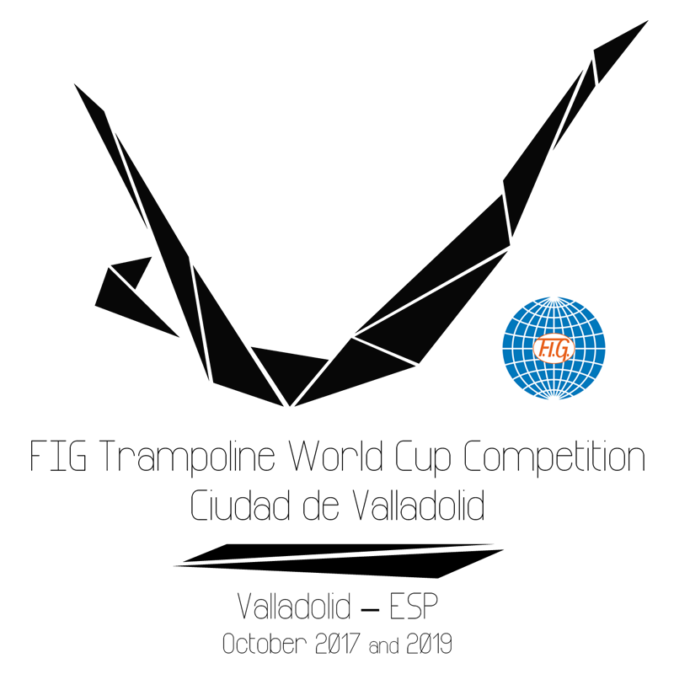

FIG Trampoline World Cup

“Ciudad de Valladolid”
Valladolid - ESP
October 7th – 8th 2017

Form to be sent to:
Organizing Committee / Host Federation
Federación de Gimnasia de Castilla y León
Apdo. 6210. 47080 Valladolid. SPAIN
Phone number: +34 637873223
E-mail: mvicentem@yahoo.es ; sgarcia@rfegimnasia.es
Deadline: 7TH August, 2017
ACCOMMODATION Form

FEDERATION |  | Contact person:
FEDERATION |  | Phone:
FEDERATION |  | E-mail:

Package / Hotel name | Room type  (i.e. single/double/triple) | Arr. day | Dept. day | LAST NAME,  First Name | Function | Price per person per night | # of nights | Total
 |  |  |  |  |  | GRAND TOTAL

Special requirements

Place and date | Seal of the NF | NF authorised signature
 |  | Signature of the President or Secretary General of the FIG affiliated NF

